HEADER:

9512-JP COLLEGE OF ENGINEERING, Ayikudi,

Department of electronics and communication engineering

Title : Smart Water fountation Phase - 5

Team members:

R. harish : [harishrgul@gmail.com](mailto:harishrgul@gmail.com)

J. sivalingam : [sivalingamj123@gmail.com](mailto:sivalingamj123@gmail.com)

L. mariraj : [marirajlaksumanan@gmail.com](mailto:marirajlaksumanan@gmail.com)

Mohammed ishok : [ishackissz@gmail.com](mailto:ishackissz@gmail.com)

**1.Objective:**

The objective of this project is to create a Smart Water Fountains system that leverages Internet of Things (IoT) technology to monitor and manage water resources efficiently.

The project aims to reduce water wastage, prevent leaks, and ensure the sustainable use of water in urban and rural environments.

**IoT Device Setup:**

The project involves the deployment of various IoT devices for data collection, control, and communication. Here are the key components of the IoT device setup:

**Fault Detection Sensor:**

Sensors used in the monitoring of machinery with the object of identifying fault.

**Flow Sensors:**

Flow sensors are placed in water distribution pipelines to measure water flow rates and detect any irregularities or leaks.

**Ultrasonic Sensors :**

For water level measurement and flow meter for flow rate measurement.

**Water Level Sensors:**

These sensors are deployed in water storage tanks and reservoirs to monitor water levels and trigger refill requests when necessary.

**IoT Gateway:**

A central IoT gateway collects data from all the sensors, preprocesses the data, and sends it to a cloud-based platform for analysis and control.

**2. Platform Development:**

The project's platform development involves creating a cloud-based system for data analysis, visualization, and control. The platform consists of the following components:

**Cloud Data Storage:**

Data collected from the IoT devices is stored in a cloud database for realtime and historical analysis. Services like AWS, Azure, or Google Cloud can be used for this purpose.

**Data Analysis and Prediction:**

Machine learning models are developed to analyze the data and predict water quality, consumption trends, and leak detection. These models help in making informed decisions.

**Control System:**

The platform can send commands back to the IoT devices to control water flow, shut off supply in case of emergencies, or trigger maintenance alerts.

**Dashboard:**

User-friendly dashboards are created for water authorities, environmental agencies, and consumers to access real-time information about water quality, consumption, and alerts.

**3. Code Implementation:**

The code for this project will be written in various programming languages, depending on the component:

**IoT Device Code:**

Each IoT device has its own code to read sensor data and transmit it to the IoT gateway. This code may be written in languages like C, Python, or platforms like Arduino.

**IoT Gateway Code:**

The gateway has code to aggregate data, perform preprocessing, and securely transmit it to the cloud. Communication protocols like MQTT or HTTP may be used.

**Cloud Data Storage Code:**

Setting up and managing databases can be done using cloud providers' services and APIs.

**Data Analysis and Prediction Code:**

Machine learning models are implemented using Python, along with libraries like TensorFlow, scikit-learn, or specific water quality analysis tools**.**

**Dashboard Code:**

Web-based dashboards can be developed using HTML, CSS, and JavaScript, along with frameworks like React or Angular.

**4. Explanation in Detail:**

The project monitors water quality, flow rates, and levels to ensure efficient Water Fountains. Machine learning models help in early detection of water quality issues and leaks, allowing for preventive actions.

Dashboards provide easy access to real-time data and alerts for decisionmakers, enabling them to take timely actions to conserve water resources, prevent contamination, and ensure sustainable water usage.

This project's success contributes to better water quality, reduced water wastage, and more efficient water distribution, benefiting both the environment and the community.

**URL for Tinkercad Project of Smart Water Fountains:**

[https://www.tinkercad.com/things/7RNCA5npEiY-copy-of-automatic-smart-water-container-miniproject/editel?tenant=circuits](https://www.tinkercad.com/things/7RNCA5npEiY-copy-of-automatic-smart-water-container-mini-project/editel?tenant=circuits)

**Screenshot of Smart Water Fountains Circuit:**

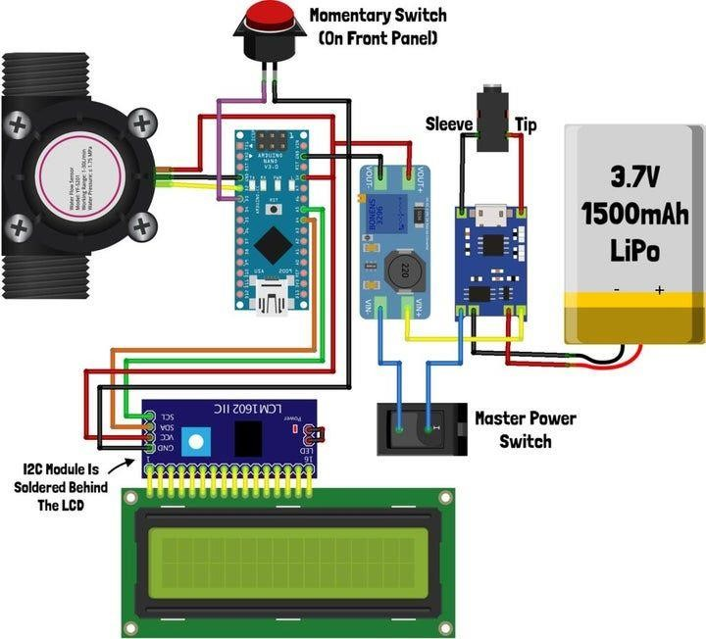

**Code for Running above Circuit:**

# Import the necessary library import tinkercad import requests # Add the requests library for HTTP requests

# Initialize the Tinkercad API

tc = tinkercad.Tinkercad(username="vignesh03", password="vignesh")

# Find the simulation you want to run (use the correct ID) simulation_id = "2303774" # Get the simulation simulation = tc.get_simulation(simulation_id) # Define the ThingSpeak API parameters thingspeak_api_key = "G5YN4PEKH3VEQ0JA" thingspeak_url = f"https://api.thingspeak.com/update?api_key={thingspeak_api_key}"

# Define the code to run in the Arduino arduino_code = """

#include <Ultrasonic.h>

Ultrasonic ultrasonic(2, 3); // Trigger (pin 2), Echo (pin 3) void setup() {

Serial.begin(9600);

}

void loop() { float distance = ultrasonic.Ranging(CM);

Serial.println(distance);

// Send data to the computer (Python script)

Serial.print("D:");

Serial.println(distance);

delay(1000);

}

"""

# Upload and run the code in the simulation simulation.run_code(arduino_code)

# Monitor the water level and send data to ThingSpeak while True:

data = simulation.get_serial_data() if data and data.startswith("D:"): distance = float(data[2:]) print(f"Water level: {distance} cm")

# Send data to ThingSpeak

try:

response = requests.get(f"{thingspeak_url}&field1={distance}") if response.status_code == 200:

print("Data sent to ThingSpeak successfully.")

else:

print("Failed to send data to ThingSpeak.")

except Exception as e:

print("Error sending data to ThingSpeak:", str(e))

**Thingspeak Channel stats of Smart Water Fountains:**

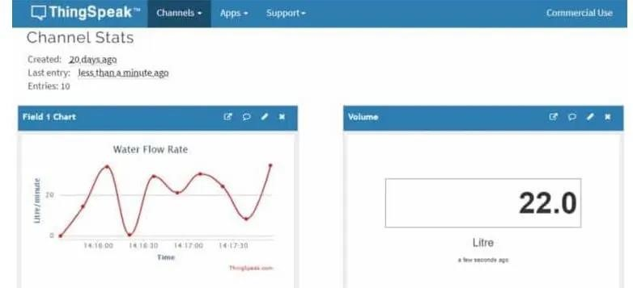

**Platform UI code for Smart Water Fountains:**

<!DOCTYPE html>

<html>

<head>

<title>Smart Water Fountains</title>

<style>

/* Style for the water level display */

#water-level { font-size: 24px; font-weight: bold;

}

/* Style for the submit button */

#submit-button { padding: 10px 20px; font-size: 18px;

}

</style>

</head>

<body>

<h1>Smart Water Fountains</h1>

<p>Water Level: <span id="water-level">Loading...</span> cm</p>

<button id="submit-button" onclick="sendDataToServer()">Submit Data</button>

<script>

// Function to update water level data from the server function updateWaterLevel() {

// You can use AJAX or fetch to get data from your server

// Replace the URL with the actual endpoint that provides water level data fetch('/getWaterLevelData') .then(response =>response.json())

.then(data => { document.getElementById('water-level').textContent = data.waterLevel + " cm";

})

.catch(error => { console.error('Error fetching water level data:', error);

});

}

// Function to send data to the server (e.g., to trigger data collection) function sendDataToServer() {

// You can use AJAX or fetch to send data to your server

// Replace the URL with the actual endpoint that handles data submission fetch('/submitData', { method: 'POST' })

.then(response => {

if (response.status === 200) {

console.log('Data submitted successfully');

} else {

console.error('Data submission failed with status:', response.status);

}

})

.catch(error => { console.error('Error submitting data:', error);

});

}

// Update water level initially and then at regular intervals

updateWaterLevel(); setInterval(updateWaterLevel, 10000); // Update every 10 seconds

</script>

</body>

</html>

**Output for above Program:**

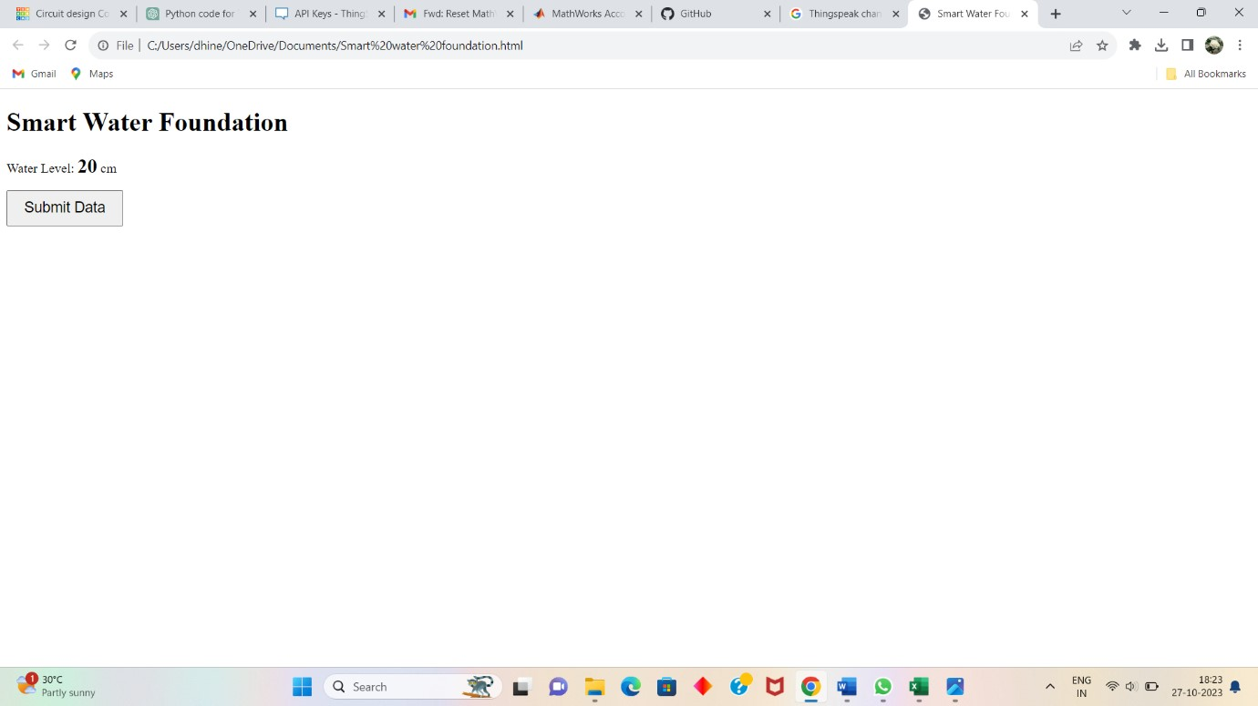

**Conclusion:**

Keeping the record of usage of water using this experiment will help in solving the water deficiency problem. This paper represents the model design and scope of the SMART WATER FOUNTAIN [ FLOW RATES ] for solving the water deficiency problem.

The volume of water was successfully calculated using an ultrasonic sensor which is used to calculate the variable height of water through the pipe. A GSM module sent the signal once the threshold volume was reached in the form of SMS. The proposed system helps every house and society to reduce the wastage of water significantly and hence the water scarcity.

**Future Scope** :

The proposed system can solve almost all the problems faced by the existing water meters. There is also scope for adding a feature which will automatically limit the flow of water into particular house or public fountain

For this feature a solenoid valve can be installed inside water flow meter so that when it rotates inside the meter then flow of water can be minimized.

**References :**

020 IEEE Pune Section International Conference (PuneCon) | 978-1-7281-9600-8/20/$31.00 ©2020

IEEE | DOI: 10.1109/PuneCon50868.2020.9362468

Ejiofor V., Oladipo O., Microcontroller based automatic water level control system, International Journal of Innovative Research in Computer and Communication Engineering, Vol. 1, Issue 6, August 2013, 1390-1396.

Kumura T., Suzuki N., Takahashi M., Tominaga S., Morioka S., Ivan S., Smart water management technology with intelligent sensing and ICT for the integrated water systems, NEC Technical Journal, Vol. 9, No. 1, January, 2015, 103-106.

Meng Hua,Wang Hui, High-Precision Flow Measurement for an Ultra-sonic Transit Time Flowmeter, 2010 International Conference on Intelli-gent System Design and Engineering Application,13 Oct 2010,Changsha ,China.

Fan Shunjie,ZhouYeu, A multi-frequency ultrasonic flowmeter applicable to liquid with gas bubbles 2011 IEEE International Instrumentation and Measurement Technology Conference,10 May 2011,Binjiang ,China.